Girl Scouts of Eastern South Carolina

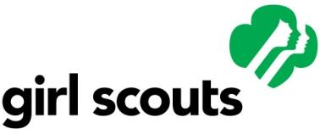

First Report of Accident/Injury

Complete all information and attach to completed GSUSA Mutual of Omaha Claim Form. Submit immediately to: Girl Scouts of Eastern South Carolina, North Charleston Service Center, 7257 Cross County Rd, North Charleston, SC, 29418.

Name of Injured:Click here to enter text.Age: Click here to enter text.Troop #: Click here to enter text.

Parent/Guardian’s Name: Click here to enter text.Address: Click here to enter text.

Home Phone: Click here to enter text. Work Phone: Click here to enter text.

Injury/Accident occurred: Date Click here to enter a date.Time Click here to enter text.LocationClick here to enter text.

Describe how the injury/accident occurred and the nature of the injury involved

Click here to enter text.

Who gave the first aid? Click here to enter text.

Describe first aid given: Click here to enter text.

Was injury caused by disobeying any rule or regulation in force at the time of the injury/accident?

Click here to enter text.

Was the injured person negligent? Click here to enter text.If so, in what way? Click here to enter text.

Was an object or equipment connected with the injury/accidentClick here to enter text.

What?Click here to enter text. How? Click here to enter text.

Did unsafe activity by an individual contribute to injury/accident? Click here to enter text.

Explain: Click here to enter text.

Witnesses: Click here to enter text.

The events described above are true and accurate to the best of my knowledge.

Signature Click here to enter text.Date Click here to enter a date.

**By typing my name in the box above I am offering my digital signature in lieu of my handwritten signature. I understand that my digital signature carries the same legal bindings as my handwritten signature.**

Home Phone: Click here to enter text. Work Phone: Click here to enter text.